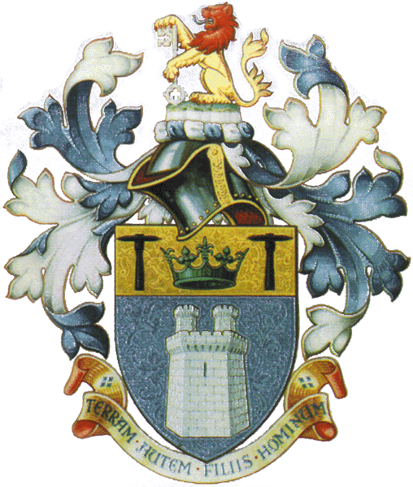THE INSTITUTE OF QUARRYING
NEW ZEALAND INCORPORATED

Summary of
Submission on the New Zealand Government’s proposed changes to the Health & Safety in New Zealand Mining Industry
From
The Institute of Quarrying New Zealand (Inc.)

Introduction

The Government is proposing significant changes to the health and safety regulations for mining in order to implement the recommendations of the Royal Commission on the Pike River Coal Mine Tragedy. It has committed to implementing these recommendations by the end of this year (2013).
It has released discussion documents that outline the regulatory proposals and this submission is in reply to the consultation documents provided by the Ministry of Business, Innovation and Employment (The Ministry). These consultation documents were made available from May 2013.
The Ministry states that the proposals are aimed at bringing health & safety in the NZ Mining Industry in line with International best practice and that they will help create a viable mining sector in NZ that the public can have confidence in, and which will enhance safety for workers and improve performance in the sector.
The Ministry is, through this proposal, seeking to broaden the Royal Commission’s recommendations concerning underground coal mines to cover all types of mining.
Key Points

- The Royal Commission had not contemplated that the New Zealand Government would introduce their recommendation to cover all extractive industries, both underground and surface, when the report was released. The Royal Commission made its recommendations based on underground coal mining. This has led to a large number of unintended consequences for the Quarry Industry.

- The Institute of Quarrying New Zealand (Inc.) (IOQNZ) does not believe that the Queensland Coal Mining Regulations are an “international best practice’ option for the New Zealand Surface Extractive Industry, more especially the Quarry Industry. Even the Queensland small mines and quarries operate under different regulations, namely the Queensland Metalliferous Mining Regulations.
- The IOQNZ strongly supports an upgrade of the New Zealand Quarries and Tunnels Act (1982) in conjunction with the Quarries Regulations (1983), which would include the additional recommendations from the Royal Commission of the Pike River Coal Mine Tragedy (RCPRCMT). The original legislation was only repealed when the HSE Act 1992 came into being and this upgrade would give the Surface Extractive Industry, ie the Quarry Industry, its own clear set of regulations and meet the outcomes from the enquiry.

- The IOQNZ proposes that ALL quarries (no exceptions) and not just those identified as being “In Scope” be included in the new legislation and that the definition from the Quarry and Tunnels Act (1982) is a much more exact definition. This would raise the H & S standard for all quarries, not only the sites that are “in scope”. Also, the IOQNZ would suggest that operators of portable crushing and/or screening plants, whether for aggregate, sand or recycled materials be included, irrespective of their working locations. These operations should have a manager with an appropriate Certificate of Competency. The 1982 Act also gives a clear definition of a tunnel.

- The IOQNZ is willing to assist the government with reviewing the Quarry and Tunnels Act 1982 and the Quarries Regulations 1983 and upgrading these to meet all the requirements of the RCPRCMT. These revised regulations would then be applicable to all quarry operations and will remove any ambiguity from the adapted Queensland Coal Mining Regulations.

- The Quarry Industry is different to Underground Mining and other extractive industries, as recognised by specific Quarries and Tunnels Act (1982) and the Quarries Regulations (1983) prior to the H & S Act 1992.

- The new regulations will apply to any site with “Principal Hazards”, where there is the potential for “multiple fatalities” in a single event. It should be noted here that the Quarry Industry has not had a “multiple fatality” in the industry for at least 30 years.

- The proposed new and revised safety critical roles outlined in the table on page 29 (vol.1) clearly shows that an Electrical Engineering Manager, Mechanical Engineering Manager & Mine Surveyor are all required for Quarries. The IOQNZ supports these positions for underground mining, but questions their need in a Quarry. Any electrical and mechanical work required in a quarry can be carried out by suitably qualified industrial trained electrical and mechanical tradesmen, who operate on a contractual “as required” hourly basis as reflects the scale of the Quarry Industry

- The IOQNZ supports all quarry workers that work in a quarry or process operation (excluding Admin staff, and customers) holding a minimum qualification. We believe that an introductory Level 2 qualification is adequate. Also, need to ensure the minimum standard is achievable for quarry workers that have left the education system in schools to become machine operators because they dislike the written skills based assessments. These people are the back bone of the quarry industry and are equally as important as the quarry manager.

- The IOQNZ strongly supports the role of a new Crown Agency focused on H & S in the Extractive industry, as this will improve H & S not only in the quarry industry, but all other extractive industries. It must have the resources to promote H & S, take a proactive role in extractive industry not only the compliance based functions we have currently. The Quarry Industry would consider a contribution to the agency to ensure that there are sufficient appropriately trained inspectors to meet all legislative requirements.

- The IOQNZ supports CPD being part of holding and retaining a CoC. Currently the IOQNZ is introducing an online system to record and audit CPD for all its members. This CPD is based on the Institute of Quarrying UK’s CPD programme, which was presented at the Quarry NZ conference in 2009.

- The IOQNZ supports the proposed Board of Examiners. However, there needs to be clarity on who would form the Examination Panel, appointed by the Board. Each branch of the extractive industry should have a specialist representation on the Examination Panel.

- The IOQNZ understands the need to appoint a SSE for a site with a high employee numbers, such as an underground coal mine. However, we believe that the employee numbers in a typical quarry do justify the appointment of a separate SSE and we would propose that the certified site manager be given the training to allow the obligations of a SSE to be met. In addition there is a proposal that the SSE can be appointed for sites that are adjacent. In the Quarry industry, although there are some companies with multiple sites, they are not what we would call adjacent being some 20, 50 or even 100kms apart. Hence our support for the site manager of every quarry is trained to meet the requirements of the SSE.

- The IOQNZ would propose that all the transition periods be changed to five years as is the current time frame for the renewal of a CoC with the ITO.

- For the Life Time License Holders, who have held their licenses for at least 20 years, the IOQNZ would recommend that by the end of this proposed transition period these License Holders will have achieved the necessary training to fulfill the recommendations of the RCPRCMT. The numbers of Life Time License Holders (estimated at some 500) would clearly overwhelm the Examination Panel if this transition period was to remain at 3 years. Add in all the other CoCs that require renewing during the same period, the IOQNZ believes that the Examination Panel would be a full time Appointed Panel during the proposed 3 year transition period and remain so as all holders will be renewing their certificates every 3 years. By taking this practical approach to these license holders it will allow them to be able to pass on their collective knowledge to those just starting out in the Quarry Industry. Over this proposed 5 year transition period there will be a number of the Life Time License Holders who will naturally retire and so lessen the work load on the Examination Panel.

The IOQNZ would like to reiterate its offer to assist the Government in revamping the Quarry and Tunnels Act (1982) and the Quarries Regulations (1983) to meet the recommendations from the RCPRCMT.

