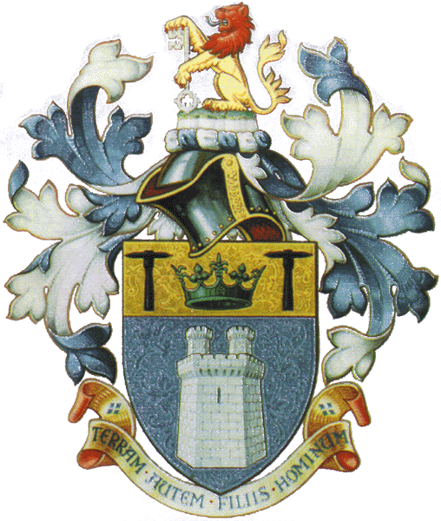THE INSTITUTE OF QUARRYING
NEW ZEALAND INCORPORATED

Submission on the New Zealand Government’s proposed changes to the Health & Safety in New Zealand Mining Industry
From
The Institute of Quarrying New Zealand (Inc.)

Who is the Institute of Quarrying New Zealand (Inc.)?
The Institute of Quarrying New Zealand (Inc.) is part of the international body of professionals for quarrying, construction materials and the related extractive and processing industries, with over 5,000 members in some 50 countries of the world.
The current membership numbers for the Institute of Quarrying New Zealand (Inc.) stands at 350.
Membership is open to individuals, rather than companies, and the Institute's long-term objective is to promote progressive improvements in all aspects of operational performance through the medium of education and training.
Our Mission Statement:
“Our mission is to promote the fellowship of members and enhance the image and professionalism of quarrying in New Zealand”
The Institute of Quarrying believes education and training is a life-long opportunity which should be viewed in the broadest terms, starting with initial qualifications gained at college, university or through distance-learning programmes. This is followed by Continuing Professional Development through attendance at conferences, seminars, training courses, competence assessment schemes, workshops, technical meetings, site visits and the updating of knowledge by reading the Institute's journals, technical and management papers and handbooks.
By utilising these resources, members not only have a means of establishing successful careers in a major industry which supplies society with some of its most basic needs, but also have the opportunity to be part of a growing network of professionals around the world committed to the advancement and sharing of knowledge.
The promotion of high standards of health and safety, together with a progressive attitude towards environmental and social responsibility, also rank prominently in the Institute's order of priorities. This manifests itself through the encouragement of best practice in both quarrying operations and community relations, so that members can be efficient producers, responsible stewards of the environment and 'good neighbours' in the areas where they work.

The Institute has several objectives and includes the following:
- Training – to actively support, promote and encourage training and education with relevant input from outside organisations
- Health & Safety – To promote and encourage best practice in relation to Health and Safety in the work place.
- Environment – To promote good environmental management practice throughout the quarrying industry.
- Relationships – To maintain and enhance relationships with other industry associations, the public, media and government through active participation.
- Image – To promote the profession of quarrying as an essential activity, vital to our way of life.
The Institute of Quarrying New Zealand (Inc.) statute is:
- To keep a watching brief on the effect of legislation both local and central and its potential effect on the industry.
- Support other Industry Associations, such as the Aggregate & Quarry Association (AQA) to ensure a unified industry-wide representation.

This submission is made in three parts:
- An introduction to the Institute of Quarrying New Zealand (Inc.) – this document.
- Summary document highlighting the key points of the submission
- A full copy of the submission document.

