
Extractive Industries Inspectorate

Promoting Safety and Health in Mining

ACCIDENT/INCIDENT ALERT

Fatal Workshop Accident at Quarry September 2004

Incident
A welder was carrying out maintenance on a quarry excavator bucket. He was using an angle grinder to prepare surfaces for welding when the disk disintegrated.

Circumstances
The hand-held angle grinder was fitted with a 230 mm diameter cutting-off wheel and when it disintegrated, fragments penetrated the victim’s chest and abdomen. He was rushed to hospital by rescue helicopter but died the same day.

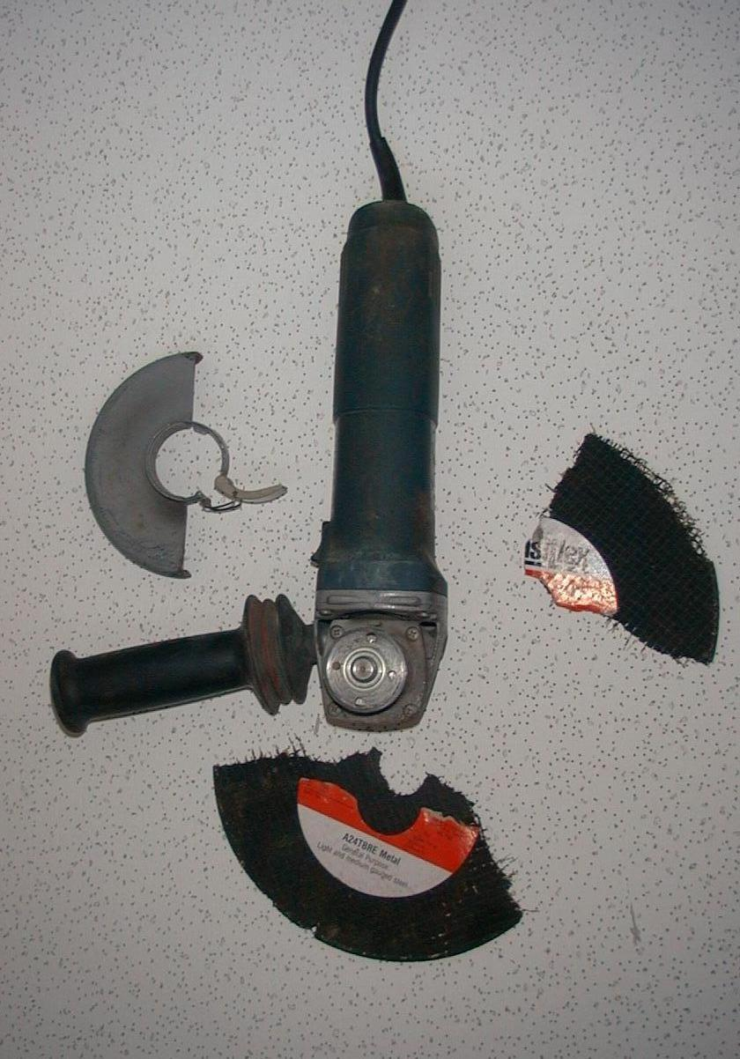

Investigation
This is continuing but initial inspections show that the grinding machine and cutting disk were not compatible - and the grinder was not fitted with a guard.

Recommendation
Grinding machines and abrasive wheels should always be used in accordance with the manufacturer’s instructions.
In particular:

- Always ensure the maximum speed (the no load rpm) marked on the abrasive wheel is greater than the rated speed of the grinder.

- Do not use grinding wheels that are larger than the maximum recommended size, or worn down wheels from other grinders.

- Never use grinding wheel power tools without the wheel guard attached to the tool and positioned for maximum safety.

- Store and handle abrasive wheels with care and inspect them for chips or cracks before installing. Do not use any wheel that may be damaged.

- Refer to Australian Standard 1788 - Abrasive Wheels

